Industrial Internship Report on
” Smart Automatic Door Control System”
Prepared by
Srirangam Lakshmi Amrutha Valli

Executive Summary
This report provides details of the Industrial Internship provided by upskill Campus and The IoT Academy in collaboration with Industrial Partner UniConverge Technologies Pvt Ltd (UCT).
This internship was focused on a project/problem statement provided by UCT. We had to finish the project including the report in 6 weeks’ time.
My project was titled “Smart Automatic Door Control System using Ultrasonic Sensor.” The objective of this project was to design and implement an automated system capable of detecting the presence of a person and operating a door without manual intervention.
This internship gave me a very good opportunity to get exposure to Industrial problems and design/implement solution for that. It was an overall great experience to have this internship.

TABLE OF CONTENTS
1 Preface 3
2 Introduction 4
2.1 About UniConverge Technologies Pvt Ltd 4
2.2 About upskill Campus 8
2.3 Objective 9
2.4 Reference 9
2.5 Glossary 10
3 Problem Statement 11
4 Existing and Proposed solution 12
5 Proposed Design/ Model 13
5.1 High Level Diagram (if applicable) 13
5.2 Low Level Diagram (if applicable) 13
5.3 Interfaces (if applicable) 13
6 Performance Test 14
6.1 Test Plan/ Test Cases 14
6.2 Test Procedure 14
6.3 Performance Outcome 14
7 My learnings 15
8 Future work scope 16

Preface
This report summarizes my six-week industrial internship conducted by Upskill Campus and The IoT Academy in collaboration with UniConverge Technologies Pvt Ltd (UCT). The internship provided valuable exposure to real-world applications and helped bridge the gap between theoretical knowledge and practical implementation.
Internships are essential for career development as they enhance technical skills, problem-solving ability, and understanding of industry requirements. During this internship, I worked on the project “Smart Automatic Door Control System using Ultrasonic Sensor,” which focuses on automatic detection and contactless door operation. 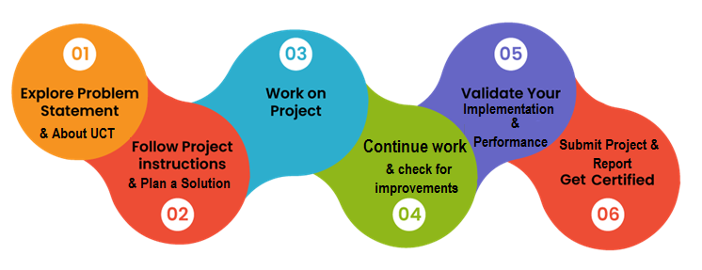
I am thankful to USC/UCT for providing this opportunity. The program was well-structured with learning sessions and project-based implementation, which helped in completing the project within the given time.
Through this experience, I gained knowledge in Arduino programming, sensor interfacing, and system design. I also improved my practical and time management skills. I sincerely thank my mentors, faculty, family, and friends for their support.
I encourage my juniors and peers to make the most of such internships, as they are highly beneficial for learning and career growth.
Overall, this internship has been a valuable and enriching experience.

Introduction

About UniConverge Technologies Pvt Ltd
A company established in 2013 and working in Digital Transformation domain and providing Industrial solutions with prime focus on sustainability and RoI.
For developing its products and solutions it is leveraging various Cutting Edge Technologies e.g. Internet of Things (IoT), Cyber Security, Cloud computing (AWS, Azure), Machine Learning, Communication Technologies (4G/5G/LoRaWAN), Java Full Stack, Python, Front end etc.
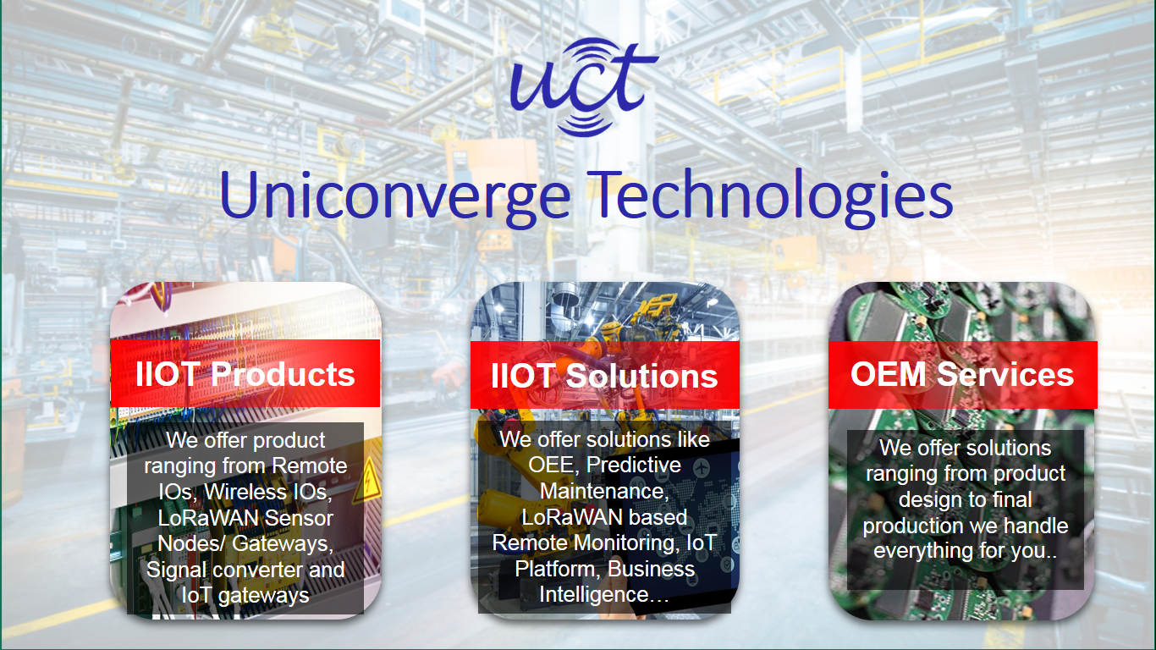
- UCT IoT Platform ()
UCT Insight is an IOT platform designed for quick deployment of IOT applications on the same time providing valuable “insight” for your process/business. It has been built in Java for backend and ReactJS for Front end. It has support for MySQL and various NoSql Databases.
- It enables device connectivity via industry standard IoT protocols - MQTT, CoAP, HTTP, Modbus TCP, OPC UA
- It supports both cloud and on-premises deployments.
It has features to
• Build Your own dashboard
• Analytics and Reporting
• Alert and Notification
• Integration with third party application(Power BI, SAP, ERP)
• Rule Engine

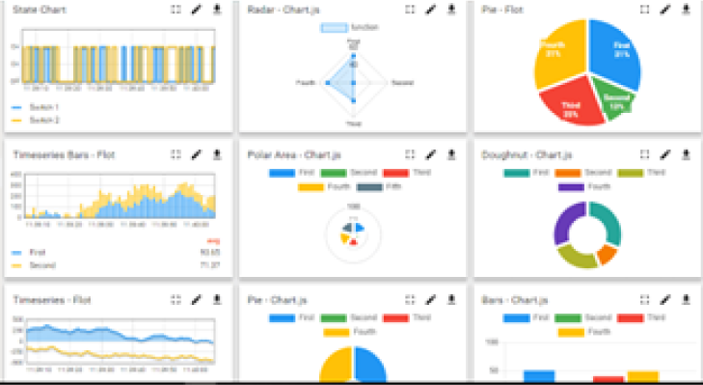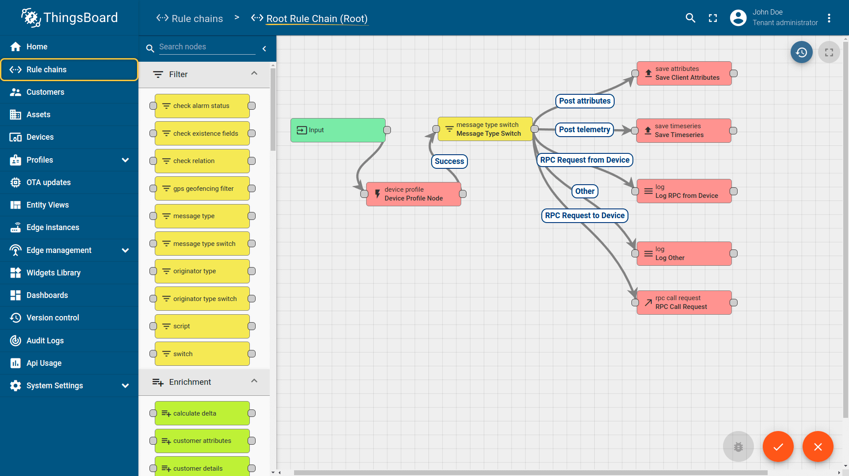

- Smart Factory Platform ()
Factory watch is a platform for smart factory needs.
It provides Users/ Factory
- with a scalable solution for their Production and asset monitoring
- OEE and predictive maintenance solution scaling up to digital twin for your assets.
- to unleased the true potential of the data that their machines are generating and helps to identify the KPIs and also improve them.
- A modular architecture that allows users to choose the service that they what to start and then can scale to more complex solutions as per their demands.
Its unique SaaS model helps users to save time, cost and money.
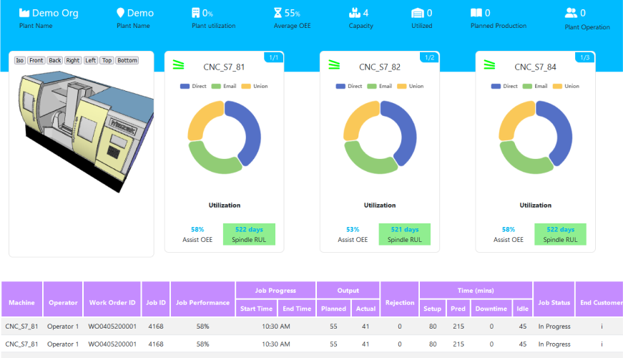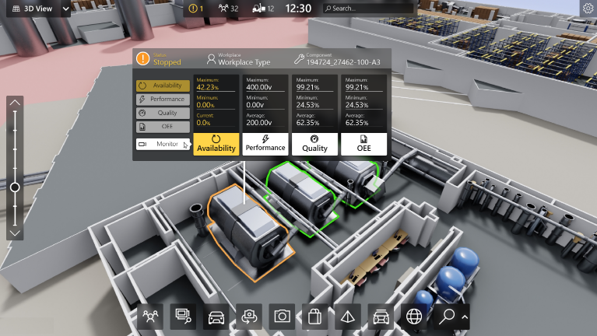

- 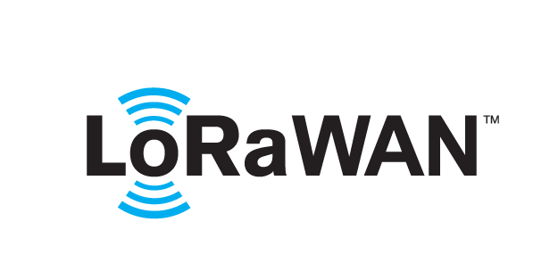 based Solution
UCT is one of the early adopters of LoRAWAN teschnology and providing solution in Agritech, Smart cities, Industrial Monitoring, Smart Street Light, Smart Water/ Gas/ Electricity metering solutions etc.
- Predictive Maintenance
UCT is providing Industrial Machine health monitoring and Predictive maintenance solution leveraging Embedded system, Industrial IoT and Machine Learning Technologies by finding Remaining useful life time of various Machines used in production process.
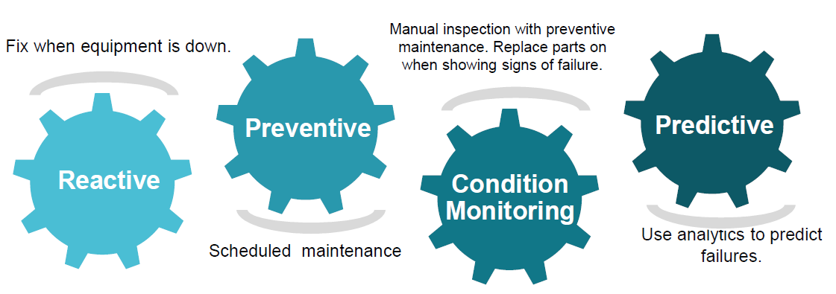

About upskill Campus (USC)
upskill Campus along with The IoT Academy and in association with Uniconverge technologies has facilitated the smooth execution of the complete internship process.
USC is a career development platform that delivers personalized executive coaching in a more affordable, scalable and measurable way.


upSkill Campus aiming to upskill 1 million learners in next 5 year






Seeing need of upskilling in self paced manner along-with additional support services e.g. Internship, projects, interaction with Industry experts, Career growth Services
upSkill Campus aiming to upskill 1 million learners in next 5 year

https://www.upskillcampus.com/

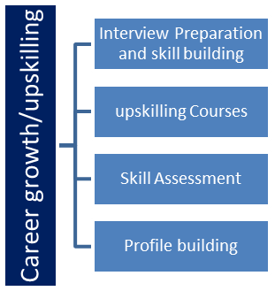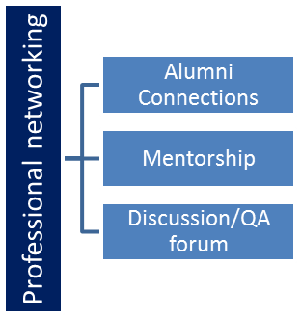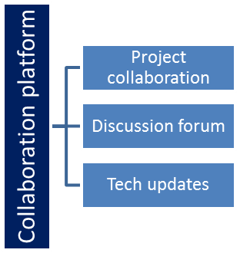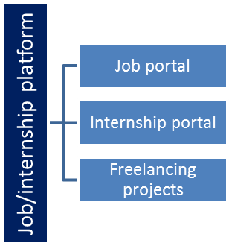

The IoT Academy
The IoT academy is EdTech Division of UCT that is running long executive certification programs in collaboration with EICT Academy, IITK, IITR and IITG in multiple domains.

Objectives of this Internship program
The objective for this internship program was to
☛ get practical experience of working in the industry.
☛ to solve real world problems.
☛ to have improved job prospects.
☛ to have Improved understanding of our field and its applications.
☛ to have Personal growth like better communication and problem solving.

Reference
[1] Arduino Official Website – https://www.arduino.cc
[2] HC-SR04 Ultrasonic Sensor Datasheet
[3] Servo Motor (SG90) Datasheet

Glossary
Terms | Acronym
Arduino Uno | MCU
Ultrasonic Distance Sensor | HC-SR04
Servo Motor | SG90
Pulse Width Modulation | PWM
Input/Output | I/O

Problem Statement
Automatic door systems are widely used in places such as shopping malls, hospitals, offices, and other public areas where ease of access and efficiency are important. Manual doors require physical effort to operate and may cause inconvenience, especially in situations where hands are occupied or for elderly and disabled individuals. Additionally, manual systems are less efficient in high-traffic environments.
The objective of this project is to develop an Automatic Door Control System Using Arduino that detects the presence of a person or object and operates the door automatically. The system uses an ultrasonic sensor to measure the distance of an approaching object. When the object comes within a predefined range, the Arduino processes the signal and activates a servo motor to open the door. Once the object moves away, the servo motor returns to its initial position, thereby closing the door.
This automated system improves convenience, reduces human effort, and ensures efficient operation. It provides a simple, reliable, and cost-effective solution for real-time automation using embedded systems.

Existing and Proposed solution
Existing Solutions
Automatic door systems are commonly used in places like malls, offices, and hospitals. These systems usually rely on sensors such as infrared (IR) or motion detectors to detect human presence. While they are effective, these systems are often expensive and involve complex installation and maintenance. In many areas, manual doors are still used, which require human effort and are not efficient in high-traffic situations.
Limitations
- High installation and maintenance cost
- Complex system design
- Not suitable for small-scale or low-cost applications
- Manual systems require continuous human effort
Proposed Solution
The proposed system is an Automatic Door Control System using Arduino, Ultrasonic Sensor, and Servo Motor. The ultrasonic sensor detects the distance of an object, and the Arduino processes this data to control the servo motor. When an object comes within a set range, the door opens automatically, and it closes when the object moves away.
Value Addition
- Cost-effective and easy to implement
- Simple design with fewer components
- Provides automatic and real-time operation
- Improves convenience and reduces manual effort

Code submission (Github link)

Report submission (Github link) : first make placeholder, copy the link.

Proposed Design/ Mode
The proposed system is an automatic door control system using an Arduino, ultrasonic sensor, and servo motor. The ultrasonic sensor detects nearby objects by measuring distance and sends this data to the Arduino. The Arduino processes the input and checks whether the distance is below a set threshold. If an object is detected, it signals the servo motor to open the door; otherwise, the door remains closed. When the object moves away, the servo motor returns to its original position, closing the door. This system operates automatically in real-time, providing a simple, efficient, and low-cost solution for door automation.

High Level Diagram (if applicable)
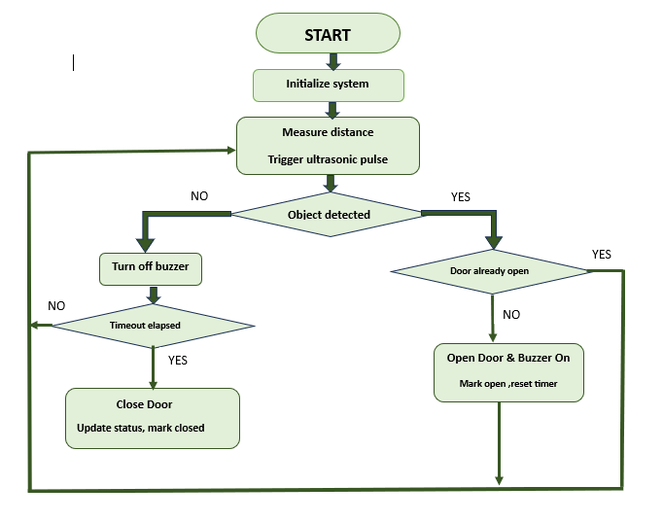

Figure 1: HIGH LEVEL DIAGRAM OF THE SYSTEM

Low Level Diagram (if applicable)

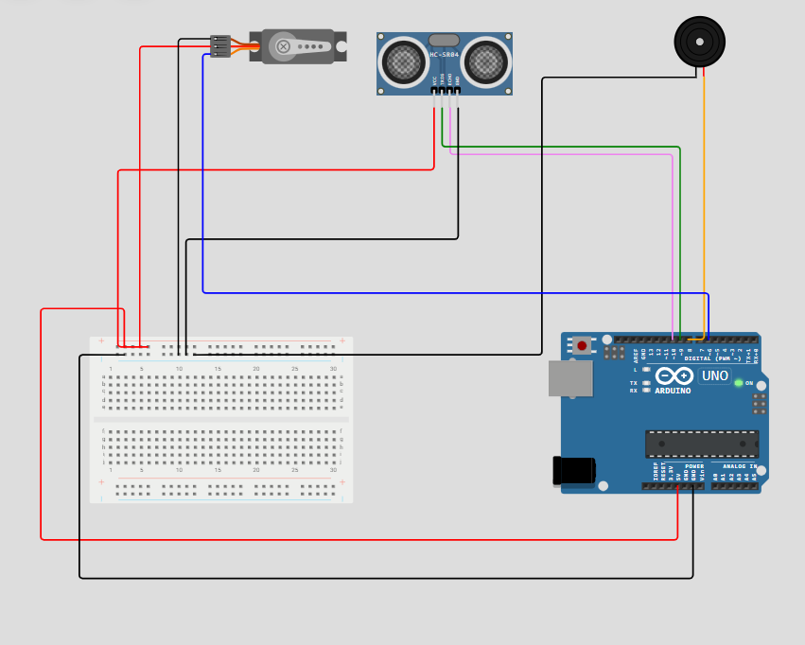

Interfaces (if applicable)
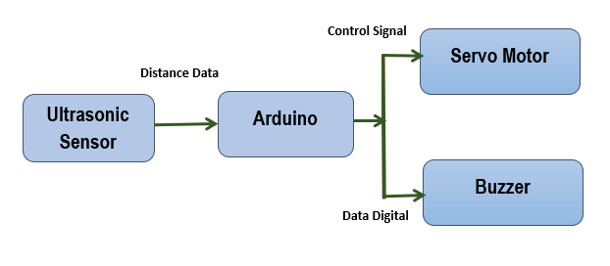
The interface diagram shows the connection between system components. The ultrasonic sensor sends distance data to the Arduino, which processes the information and controls the servo motor and buzzer accordingly.

Performance Test
he system performance is evaluated based on constraints such as response time, accuracy, power consumption, and memory usage. The ultrasonic sensors continuously send distance data to the Arduino Uno, which processes it to detect object movement and update the count efficiently. The system provides a quick response, enabling smooth real-time operation.
The accuracy of the system is reliable within a specific range, ensuring correct object detection and counting. The use of simple and optimized code helps reduce memory usage and improves processing speed. The overall power consumption remains low, making the system suitable for continuous use.
However, sensor readings may be affected by environmental conditions such as noise or reflective surfaces. To improve performance, advanced sensors, better filtering techniques, and higher-capacity microcontrollers can be used for enhanced accuracy and reliability.

Test Plan/ Test Cases
Test Case | Expected Result | Status
Object detected near sensor | Door opens automatically (servo rotates) | Passed
No object in range | Door remains closed | Passed
Object moves away | Door closes after delay | Passed
Continuous object presence | Door remains open | Passed
Verify servo motor movement | Smooth opening and closing of door | Passed

Test Procedure
➢ Powered on the Arduino Uno and initialized the system.
➢ Moved an object near the ultrasonic sensor and verified that the door opened automatically.
➢ Moved the object away from the sensor and verified that the door closed after a delay.
➢ Checked the servo motor movement for smooth opening and closing.
➢ Repeated the tests multiple times to ensure consistent operation.

Performance Outcome
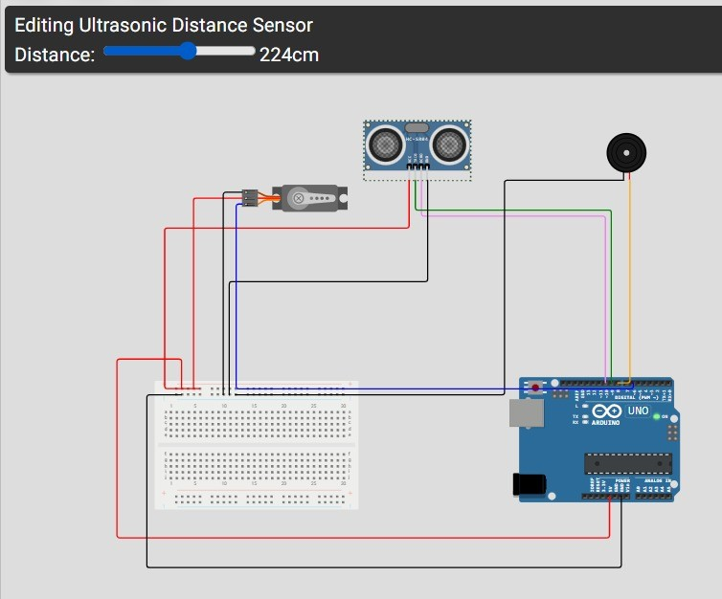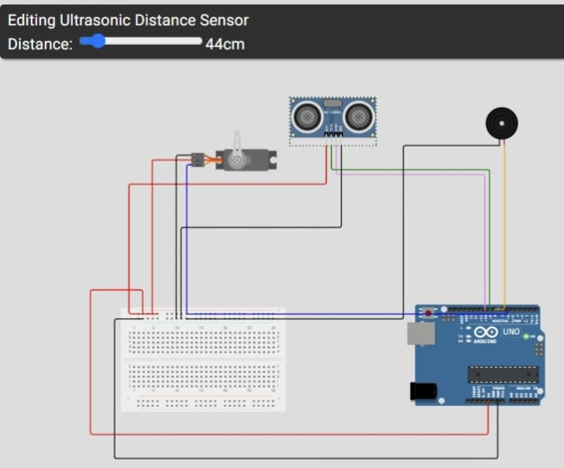
When distance > 50 cm,Door Closed
When distance < 50 cm,Door Opened

The developed Automatic Door System successfully detected the presence of objects using the ultrasonic sensor. The Arduino Uno processed the sensor data and controlled the servo motor to open and close the door automatically in real time. The system showed quick response and smooth operation during door movement.
The overall performance was reliable, with consistent opening and closing actions observed during repeated testing. The system operated efficiently with low power consumption, making it suitable for continuous use in practical applications.

My learnings

During this internship, I gained valuable knowledge about Embedded Systems and their real-world applications. The learning materials helped me understand the basics of Arduino programming, sensors, microcontrollers, circuit design, and embedded system development. I also learned the complete process of developing a project, from understanding the problem to designing, testing, and documenting the solution.
As part of the internship, I developed an Automatic Door System using Arduino Uno, an ultrasonic sensor, and a servo motor. Through this project, I learned how to interface hardware components, write Arduino programs, simulate circuits, and test the system under different conditions. I also improved my skills in creating flowcharts, block diagrams, and technical documentation.
In addition to technical knowledge, this internship enhanced my problem-solving, debugging, analytical thinking, and project management skills. It also helped me understand the importance of proper testing and documentation. Overall, this internship provided hands-on experience and increased my confidence in developing embedded system applications, which will be useful for my future academic and professional work.

Future work scope

The developed Automatic Door System can be further improved by adding advanced features and enhancements. The system can be upgraded by using more accurate sensors such as infrared or LiDAR sensors for better detection and reliability. A more powerful microcontroller can be used to handle complex operations and improve system performance.
Additional features like password-based access, RFID, or face recognition can be integrated to enhance security. The system can also be connected to IoT platforms for remote monitoring and control. Power efficiency can be improved by implementing energy-saving techniques.
Overall, these improvements can make the system more efficient, secure, and suitable for real-world industrial and commercial applications.

